How to use the Arduino IDE

The Arduino IDE has evolved to be the defacto standard of hobbyists in programming microcontrollers. It is not just and IDE , it is rather an Eco system of libraries that interfaces to many sensors and input/output devices.

In the Arduino world, we call our programs as “sketches”.

In this lesson, we try to browse through the IDE and its elements:

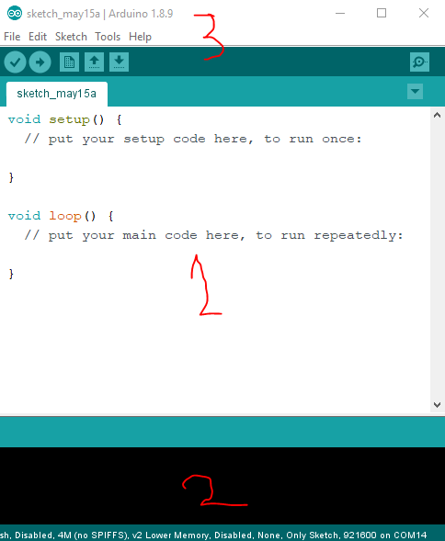
1. The code area: you will notice that a Sketch has two functions:
- setup(): which runs only once when the processor first fires up. This is used to initialize connections, set the pinMode(), Serial.begin() ...etc
- loop(): this function keeps being called every time it finishes in an endless loop. Functions like digitalRead(), digitalWrite() and Serial.println() usually used in the loop.

Who calls these functions ? The firmware of the SOC. It calls “setup()” once it gets volts running in it veins and “loop()” as long as it is breathing.

2. The output or result area: this is where the result of compilation, errors and warnings are reported. Also, shows the upload status of the program once you hit the upload button in area 3.
Notice the footer; it tells you which setup your tuned in right now, like which board and connected at which port ...etc.

3. The title bar and the menu bar.

The buttons from left to right are:
Compile | Compiles the code according to the settings you have chosen like the board type and configuration.
Upload | You can only upload a successfully compiled program , so hitting this button without compiling first will implicitly trigger compile also.
New | Creates a new *.ino file in the same sketch, more advanced feature when you want to seperate your code into multiple source files.
Open | Opens a new sketch
Save | Saves the current sketch
The Lens icon on the far right | This starts the Serial monitor

Also these functions are available from the menu and from short-cut keys :

The import menu items:

Tools:
Board (…..) | This allows you to chose which board you want your source code to be compiled for. ArduinoIDE is just an IDE, there are different tool-chains installed for each board. This usually the first mistake a rookie makes to chose the wrong board.
Port | When the development board is connected and successfully identified by the drivers and the OS, a new port should show up there. COMX fro windows and dev/XXX for Linux and OSX.
Serial Monitor | This open a seperate window and show shows feedback coming from the Development board through the same cable you used to program the Board. Serial.println() function

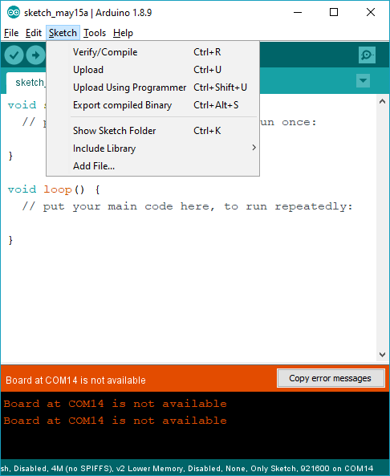

File:
Sketchbook | What every sketches in <UserHome>\Arduino\sketches folder
Examples | For each library installed there are associated example sketches

By now you realize that we call our small programs “Sketches” and we use C and C++.

If you are interested in the origins of the Arduino-IDE itself, check “https://processing.org”, you will notice the similarities between them immediately. (Setup, loop/draw)

